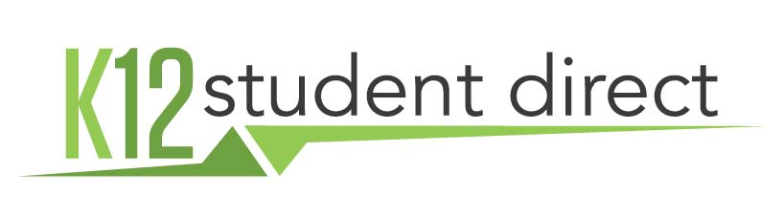

K12 Student Direct is the official partner of your school in the operation of its bookstore. K12 Student Direct has been operating school bookstores online for over sixteen years and supplied students with course materials for over seventy. The following is a guide to navigating the website. First-time users will need to set up an account; established customers can use the same log-in and password as they have in the past.
SETTING UP AN ACCOUNT
Go to www.K12SD.com. Upon arrival, you will be asked to log in or register for an account. When you are choosing a browser, please use Chrome, Firefox, or Safari to access the website. Search for and select your school. Providing a student ID is not mandatory for sign up.

FIND YOUR COURSE MATERIALS
You may search for your materials either by searching by course or searching by item. Or, you can choose ADVANCED SEARCH to select the term Summer Reading 2017, then click on SEARCH to see the list of courses. As you find each of your courses, you can add them to MY COURSES to save them or you can add items directly to your cart.

YOUR SHOPPING CART
Items may be added to the cart either one-at-a-time or in bulk. When you add items to your cart, you will be taken to the cart to review them. You can also get to the cart by selecting the SHOPPING CART button in the upper right portion of the screen.
CHECKOUT PROCESS
Checkout is designed to be simple and straightforward, minimizing the number of steps required.
1. After reviewing the details of your cart, select “Checkout.”
2. Complete shipping contact and address and select a delivery method. Most deliveries to addresses in the Northeast are shipped ground and arrive within one business day following processing. If you want to guarantee a certain number of days, we offer additional options.
3. Choose a payment method and fill in the appropriate fields related to that method.
4. Review the details of your order and select Confirm Purchase.
5. An order confirmation page will be displayed and a summary emailed to you. Please note your Order Number. Orders placed by credit card will be processed right away. Cashier’s check or money orders will be processed and shipped upon receipt of payment. Personal checks are not accepted.

RETURNS
Students have fourteen (14) days from the school’s course drop/add date to return books. Books returned for a refund must be returned in the same condition in which they were delivered.
For more information on returns, please view our policy and instructions on the website.
HAVE QUESTIONS?

Check out our list of answers to frequently asked questions or Contact Us.

Call: (877) 560-2651

Email: support@k12sd.com

Live Chat

